**期末考试题**

一共**4part** 8页 空白的位置少,写紧凑点 没有答题纸，可以在旁边打草稿

**15个选择题，30分 （一个选择题2分）**

1. 2. 3. 前面的PPT
2. 后面PPT
3. 难（不做）
4. 难 细致 估计是从哪个犄角旮旯出的题（可以放弃）
5. 简单 中间
6. 中（考试题）偏后
7. 和前面
8. 上课重点
9. 弱智
10. 上课例题
11. 上课例题
12. 偏后
13. 偏后

**简答题 2个 25分 9、16分 （有名词解释）**

1. **3小问 9分 ： Critical Path**
2. **2小问 16分：**

PPT1-6，上了一门.........课，这门课讲了什么

Five group progress and ten knowledge area

47 processes ITTO

**3个大题：12 13 8 33分**

1. Time management
2. 3. Cost management

**项目管理计划 12分**

Assignment 2中3basline包含什么 11子计划，包含什么，要解释一下

疑似题目

plan risk management P35可能是选择

Quality P13 选择题

Procurement management P25

（Chapter 10 Stakeholder Management P16 选择）

Communication Management P29

WPF分解的最小层级：工作包 ， 活动？

**work package is the work defined at the lowest level of the WBS**

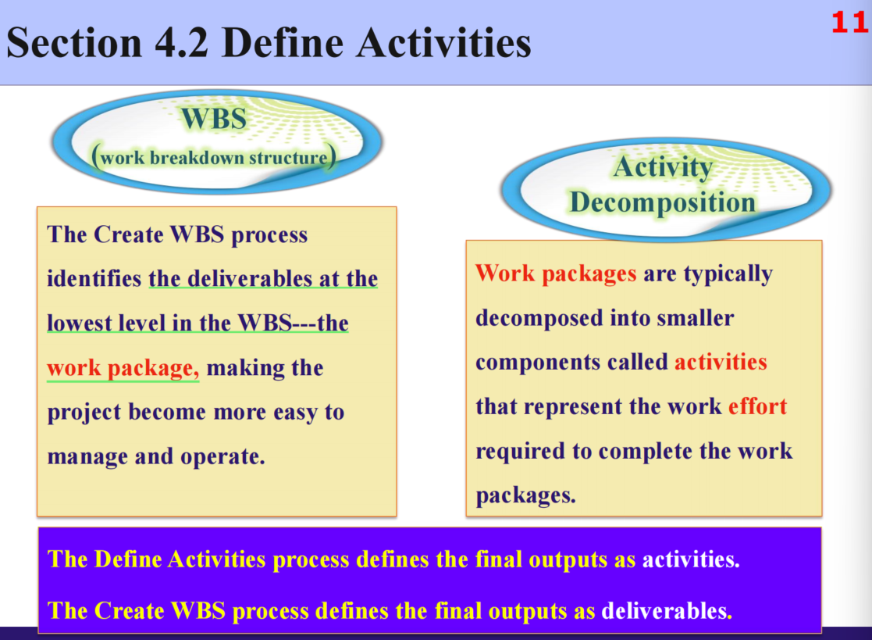

**Project Management Plan 12分**

3 baseline 11子计划，要解释一下，包含什么

**Baseline**

**- Scope baselines**

定义：is the approved version of a scope statement, WBS, and its associated WBS dictionary, that can be changed only through formal change control procedures and is used as a basis for comparison.

具体工作：1. Project scope statement

2. WBS

3. WBS dictionary

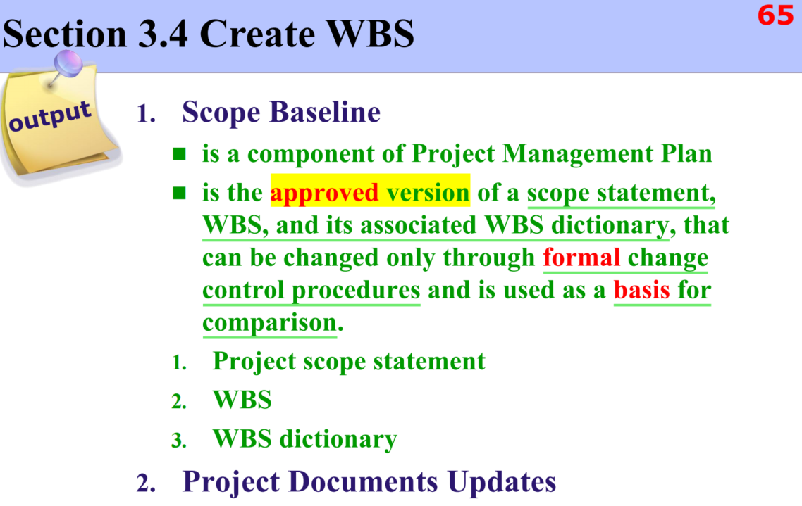

**- Schedule baselines**

定义：A schedule baseline is the approved version of a schedule model that can be changed only through formal change control procedures and is used as a basis for comparison to actual results

具体工作：Bar charts, Milestone charts, Project schedule network diagrams

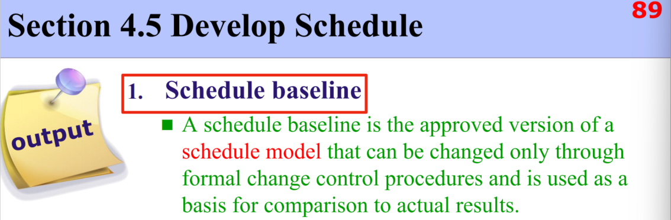

**- Cost baselines**

定义：The cost baseline is the approved version of the time-phased project budget, excluding any management reserves, which can only be changed through formal change control procedures and is used as a basis for comparison to actual results.

具体工作：time- phased view of the cost baseline （S-curve）

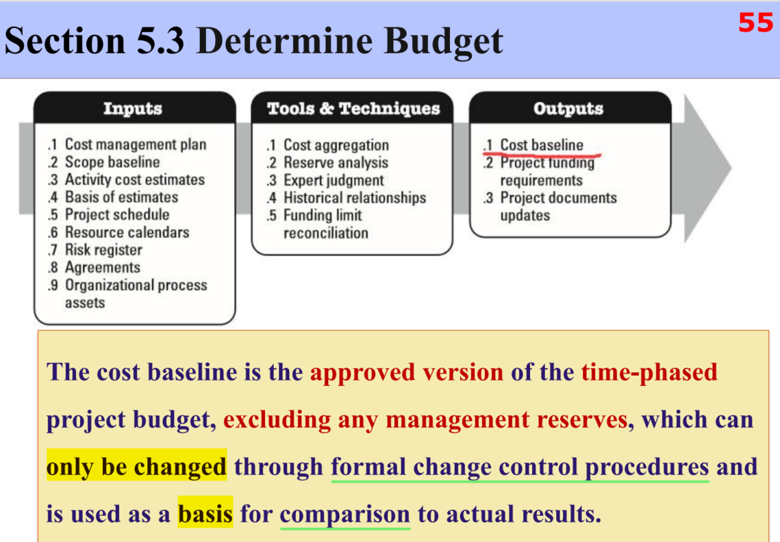

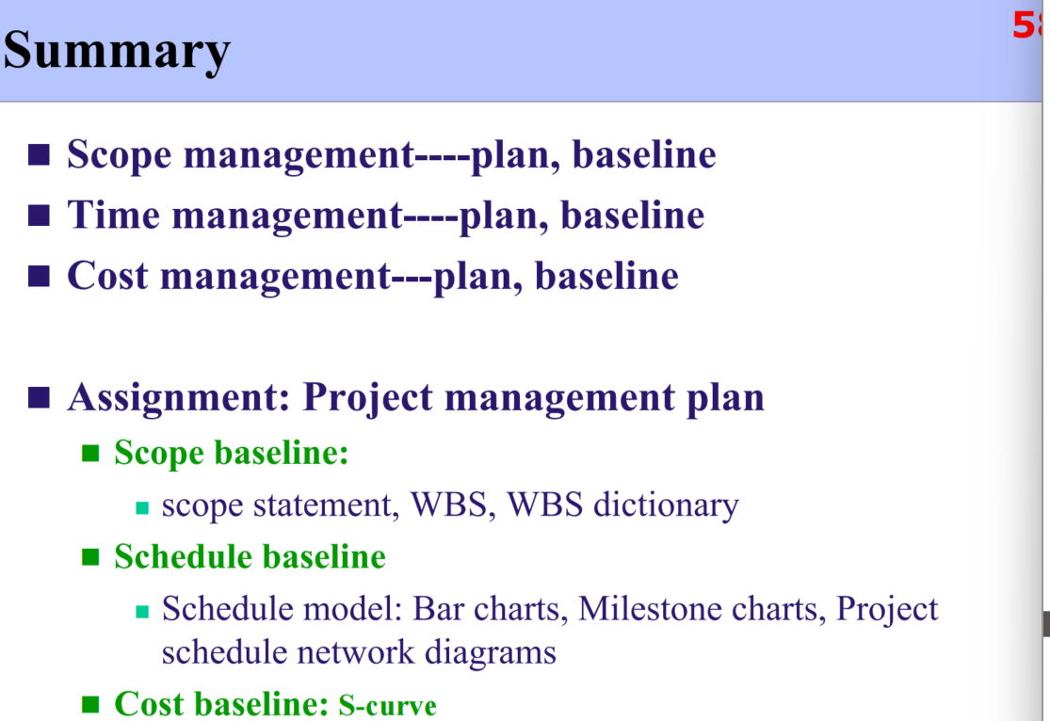

**Subsidiary plans**

**- Scope management plan**

定义： describes how the scope will be defined, developed, monitored, controlled, and validated.

具体工作：Process for preparing a project scope statement.

Process that enables the creation of the WBS（**Work Breakdown Structure**）

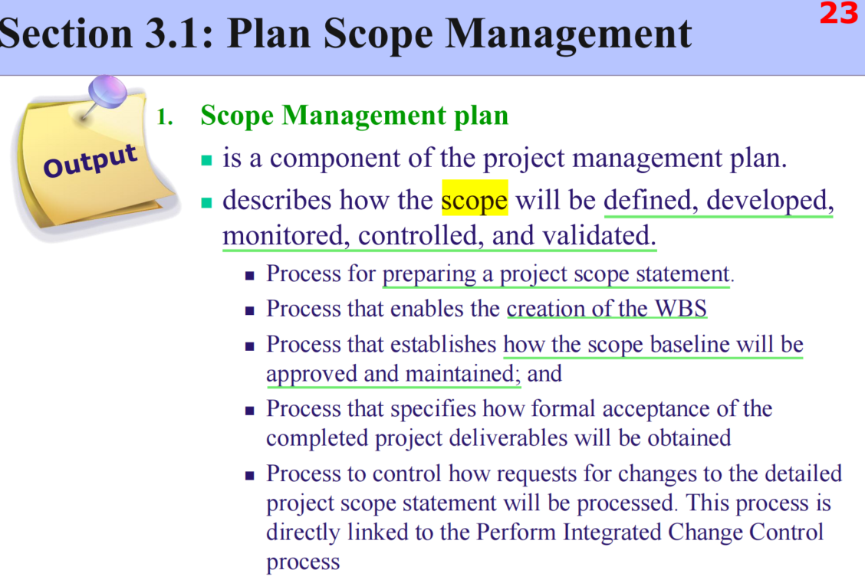

**- Requirements management plan**

定义：describes how requirements will be analyzed, documented, and managed.

具体工作：Requirements prioritization process;

Product metrics that will be used and the rationale for using them;

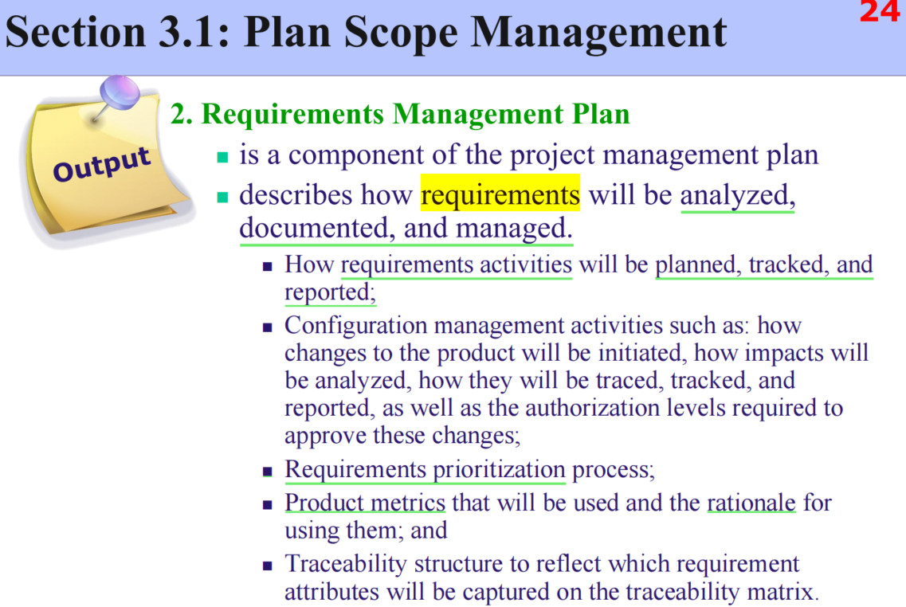

**- Schedule management plan**

定义：establishes the criteria and the activities for developing, monitoring, and controlling the schedule.

具体工作：

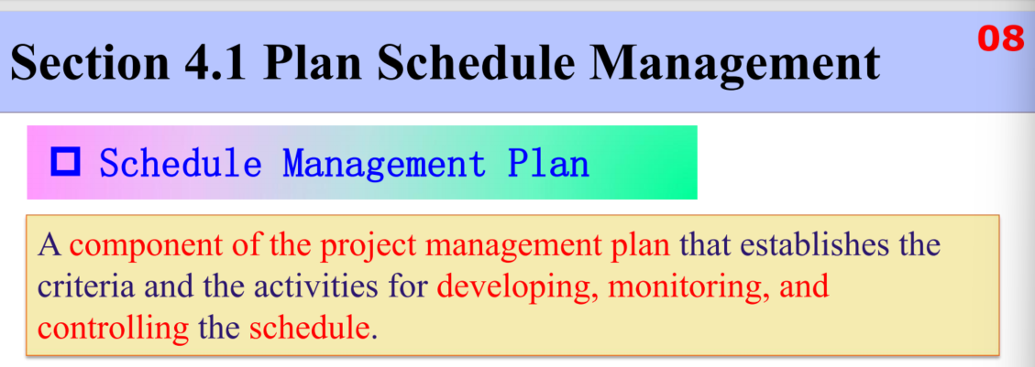

**- Cost management plan**

定义：describes how the project costs will be planned, structured, and controlled.

具体工作：Units of measure

Level of precision and accuracy

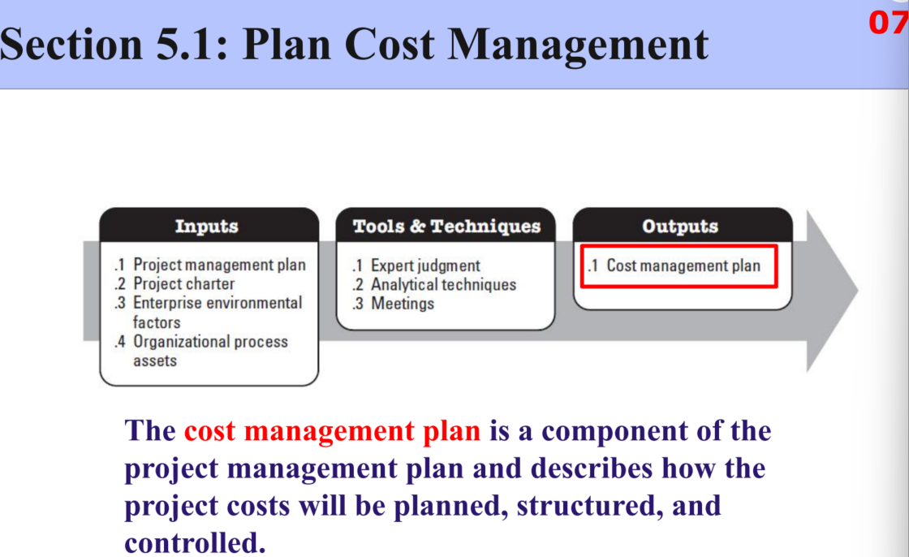

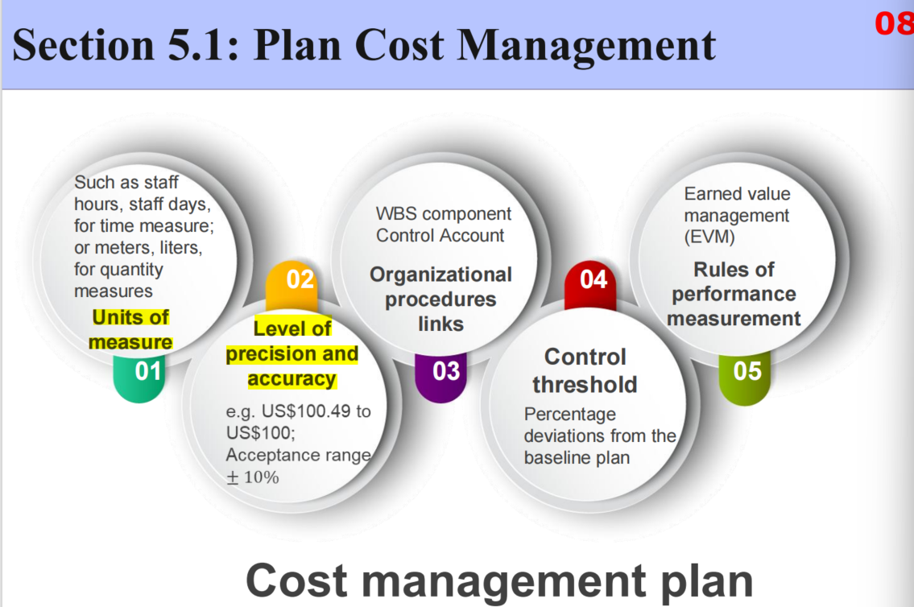

**- Quality management plan**

定义：

具体工作：

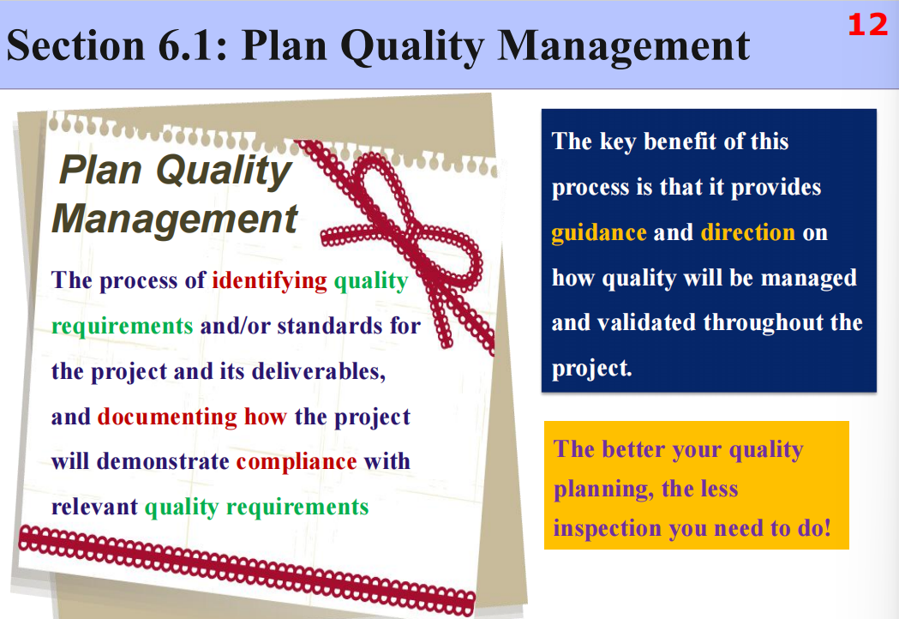

**- Process improvement plan(PPT上没有)**

定义：A structured solution for systematically optimizing work processes to enhance work efficiency or quality

具体工作：Diagnose existing problems → Implement optimization plans → Monitor effects and standardize

**- Human resource management plan**

定义：Human resource planning is used to determine and identify human resources with the necessary skills required for project success.

具体工作：describes Roles and responsibilities

Project organization charts

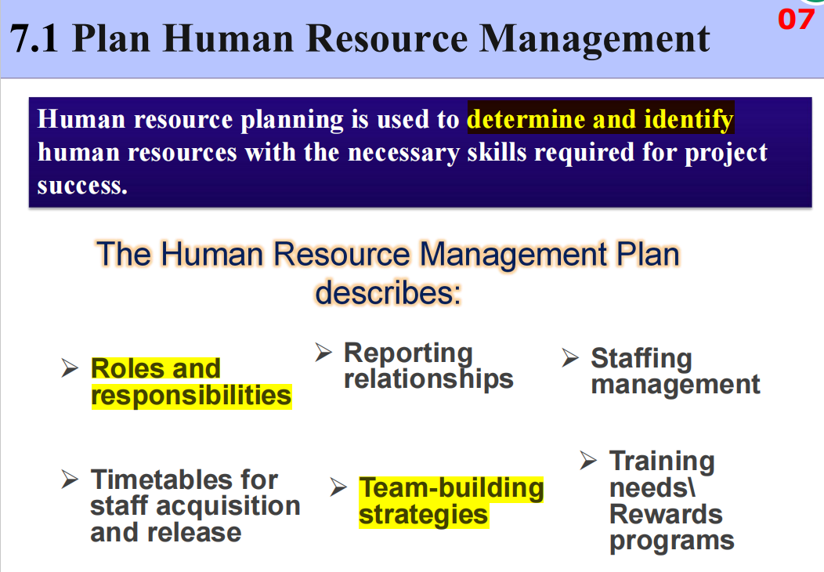

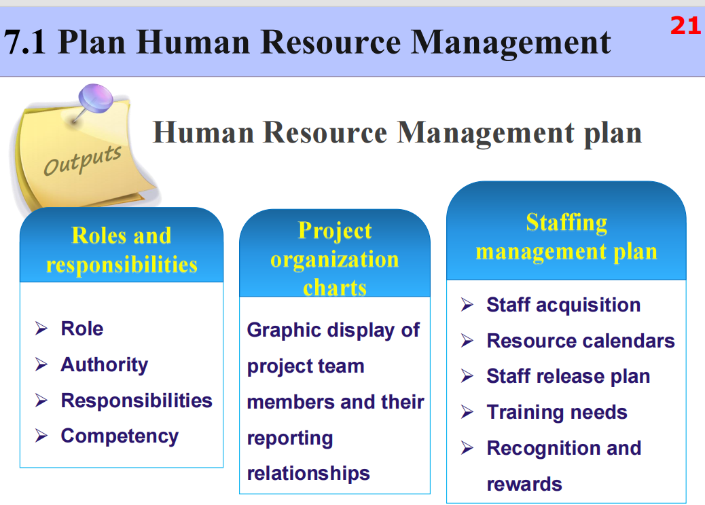

**- Communication management plan**

定义：ensure timely and appropriate planning, collection, creation, distribution,

storage, retrieval, management, control, monitoring, and the ultimate disposition of project information.

具体工作：

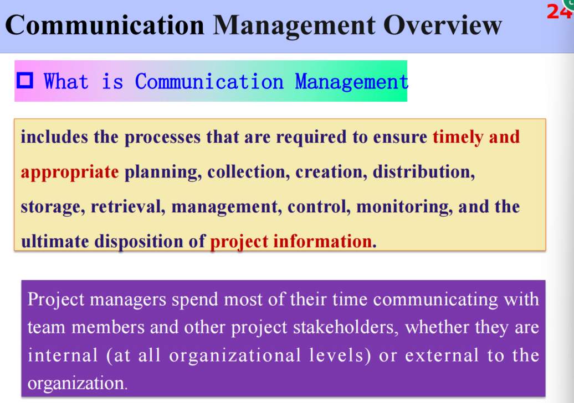

**- Risk management plan**

定义：describes how risk management activities will be structured and performed.

具体工作：Defines the approaches

Defines the risk management team members

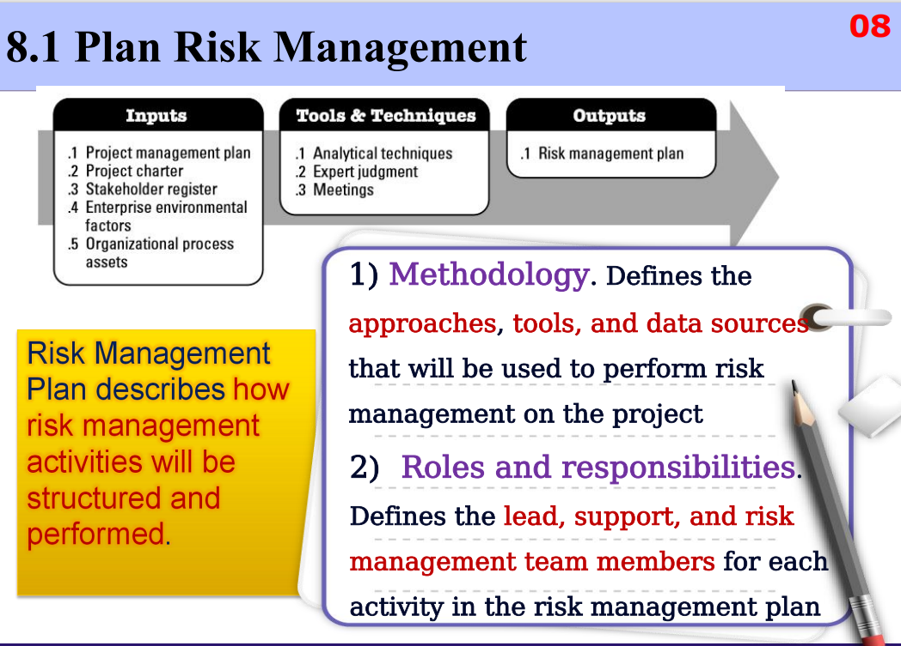

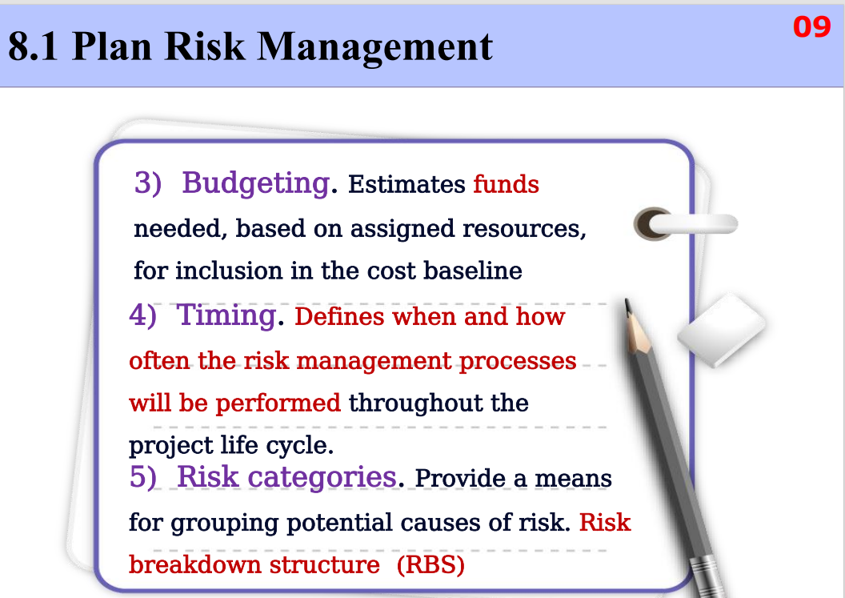

**- Procurement management plan**

定义：documenting project procurement decisions, specifying the approach and identifying potential sellers.

具体工作：evaluating potential sellers, risks

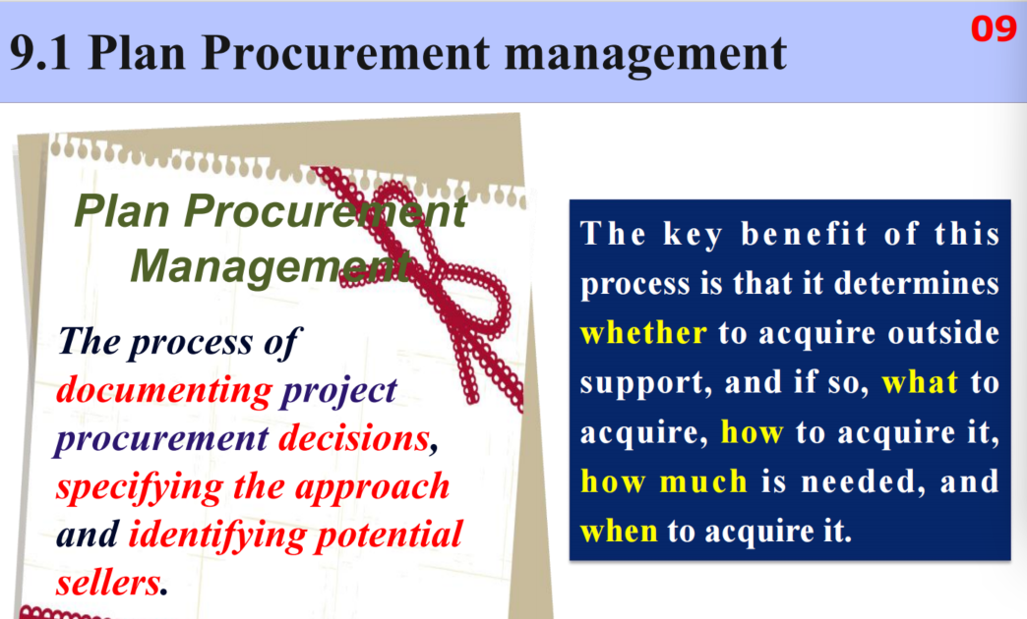

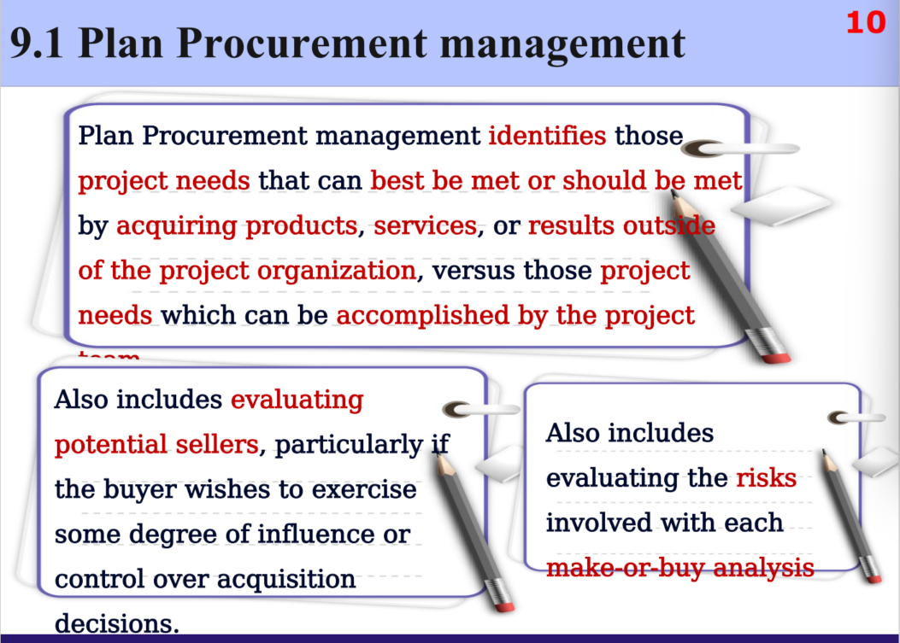

**- Stakeholder management plan**

定义：developing appropriate management strategies to effectively engage stakeholders throughout the project life cycle, based on the analysis of their needs, interests, and potential impact on project success.

具体工作：

